Independent Project

Project Title: Larrea Population

Project Overview
This project analyzes a dataset examining variation in growth environment among populations of Larrea species. The dataset was obtained from the repository maintained by the Environmental Data Initiative and includes observations collected between 2006 and 2009 from multiple geographic locations across North and South America. The study focuses on two species, Larrea tridentata and Larrea divaricata, which are desert shrubs commonly found in arid environments. Data were collected from several sites including the Sevilleta National Wildlife Refuge in New Mexico, locations in Mexico, and sites in Argentina. The dataset includes variables such as species, site location, latitude, and growth environment, which allow researchers to examine how environmental conditions differ across plant populations. The goal of this project is to investigate how growth environment varies among Larrea populations across species and geographic locations. Specifically, this project will explore whether patterns in growth environment differ between species or across different sites. I hypothesize that growth environment will vary among locations because plants growing in different regions experience different environmental conditions such as temperature, soil composition, and water availability. Understanding these patterns may help explain how environmental factors influence plant populations and contribute to processes such as Local Adaptation.

Pseudocode
First, the dataset will be imported into R from the downloaded CSV file. Next, the structure of the dataset will be examined to identify the variables and check for missing values. The data will then be cleaned by filtering out rows with missing values in key variables such as species, latitude, and growth environment. After cleaning the data, summary statistics will be calculated to understand the distribution of observations across species and growth environments. Several visualizations will then be created, including bar graphs and scatterplots, to explore patterns between species, geographic location, and growth environment. Finally, the patterns observed in the graphs will be interpreted to determine whether growth environments vary among Larrea populations across different locations.

Graphs Provided in R Script

Bar Graph: Growth Environment by Species
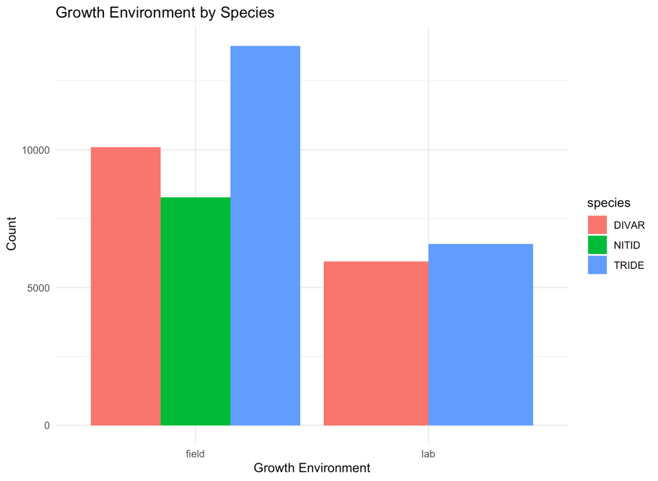
This figure shows a bar graph representing the number of different species by growth environment.

Scattered plot: Growth Environment vs. Latitude by Site
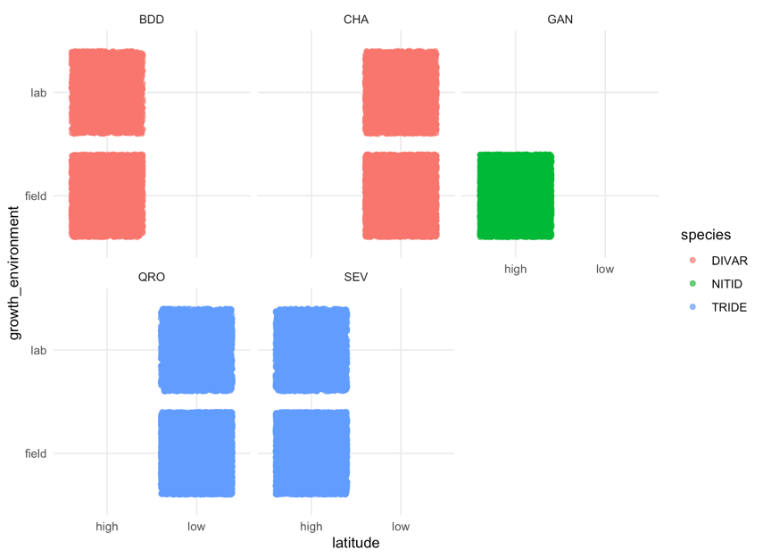
This figure shows a scatter plot representing the different species across environments and latitudes within multiple groups.

